

**User Guide**

**Presented By**



Educational Development Software (EDS) is a full-service software development company specializing in rapid software development for school districts and educational institutions of all sizes. EDS is dedicated to providing cutting edge solutions that satisfy all of your educational software needs. EDS also offers competitive services to build and maintain your school's technical infrastructure.

The information contained in this guide is subject to change without notice and does not represent a guarantee or commitment on behalf of Educational Development Software in any way. All updates or additional information relating to the contents of this guide will be posted on the HIBster web site, located at [http://www.hibster.com](http://www.hibster.com/). Access to the software is provided to you on a subscription basis. Copying or distributing any part of the software including screen shots and this guide to any potential or existing competitors is strictly prohibited. No part of this manual may be reproduced, distributed, or transmitted in any form or for any purpose without the express written consent of Educational Development Software.

Copyright © 2010-2014. Educational Development Software.

HIBster Software Copyright © 2010-2014, Educational Development Software. All rights reserved

For additional information, contact Educational Software Development at:

Educational Development Software  
PO Box 914  
Johnstown, PA 15907  
Phone 866.315.2306   
Fax 814.262.7410

**Table of Contents**

**INTRODUCTION** 5

**WELCOME** 6

**LOGIN** 7

**HOME** 8

**Return Home from Any Page** 9

**NAVIGATION** 10

**INCIDENTS** 11

**Add an Incident (Users)** 11

**Add a Victim** 12

**Add an Alleged Perpetrator** 14

**Repeat Victims and Offenders** 15

**Submit an Incident (Non-Users)** 15

**Pending Incidents Queue** 16

**Investigating an Incident** 18

**Assigning an Incident** 20

**Closing an Incident** 21

**Approving an Incident** 21

**Modify an Incident** 21

**Search Incidents** 22

**REPORTS** 23

**Reports on Individual Incidents** 23

**Incident Summary Report** 23

**Statistical Analysis** 24

**Reports on Groups of Incidents** 25

**District Summary Report** 25

**Generate Executive Report** 26

**Generate Excel Report** 27

**District & School Reports** 28

**Report/Graph Types** 29

**Yearly Breakdown Report** 30

**SYSTEM SETTINGS (System Administrators Only)** 31

1. **District Details** 31

2. **Schools** 32

**3.** **Users** 33

4. **Tasks** 34

5. **Documents** 35

**HELP & SUPPORT** 36

**Feedback** 36

**Resources** 36

**ADDITIONAL INFORMATION** 37

# **INTRODUCTION**

HIBster is an anti-bullying software program built to help school districts comply with bullying policies and mandates. Developed with administrators and teachers in mind, the program is the powerhouse of executing all necessary procedures required to meet important terms and due dates. Due to the strict nature of anti-bullying requirements, schools must take actions that are efficient, methodical, and without confusion. The HIBster software program, with its straightforward and user-friendly functions avoids disorder and uncertainty that could result from collecting and sorting sensitive information.

Applicable functions of HIBster include collecting and organizing incident data; generating reports; indicating trends such as hot spots and repeat offenders; evaluating incidents as bullying or non-bullying behavior; auto-generating documents, forms and letters; and backing up incident information. HIBster allows reports to be reviewed and modified as necessary before they must be sent to the state. All incident data is backed up on our secure server to ensure that you can access it again as necessary.

Although HIBster is quite easy to use, it is important that all users have this user guide on hand to use as a reference in the event that a particular function is not completely clear. It is better for users to become familiar with how the system works before they use it for the first time. Jumping in with both feet is possible with this software, but it is better to be prepared for the stringency of anti-bullying laws and policies.

As you read through this user guide, you will notice some words are **bolded**. These words typically highlight a term that is used as a button or link in the program. For example, if the guide instructs you to click **Submit**, then you should look for a Submit button or link on the screen.

Screenshots throughout this guide are delineated by a **blue border** and used to illustrate what your screen should look like while using a particular function. They ensure that you are in the correct place in the software. Important things to be aware of are encompassed by a **red border**.  
  
Any topics or issues not addressed in this guide may be submitted to Educational Development Software at [support@hibster.com](mailto:support@hibster.com).

**WELCOME**

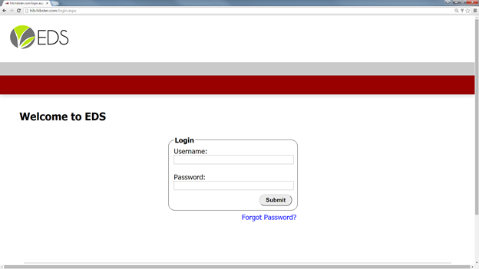

# **LOGIN**

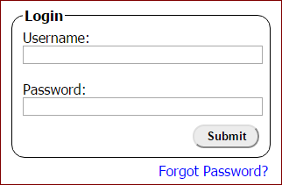

**To login:**

1. Enter a username and the corresponding password in the text boxes located in the center of the screen.
2. Click the **Submit** button.
3. If the username and password were correct, users will be directed to the Modules page.

Select Your Module

After successfully logging in, users are directed to the modules page. To enter the HIBster module, simply click the HIBster logo. It is the first of the four logos on the left side of the page.

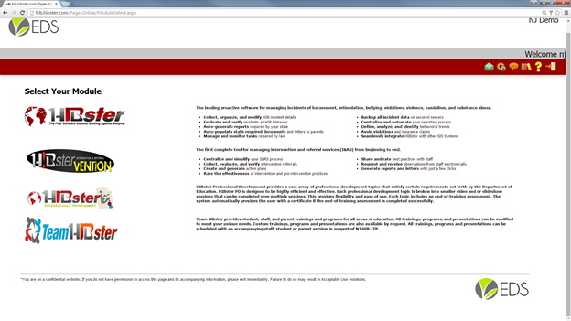

# **HOME**

After selecting the HIBster module, users are directed to the HIBster homepage.

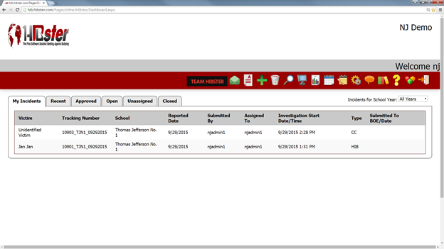

Users have access to the following items from the home page:

1. **A welcome message.** In the gray banner that runs across the top of the screen, HIBster will welcome all users by first name.
2. **Navigation buttons.** Located directly below the welcome message in the red banner are all of the navigation icons. These icons allow the users to quickly move between different sections of HIBster.
3. **Incident Manager.** Here is where users can access all of the incidents to which they have access. Such as:
   1. If logged in as a **System Administrator**, **District Coordinator**, **School Administrator**, **Specialist** or **School User** the incident manager will feature the following navigational tabs: My Incidents, Recent, Approved, Open, Unassigned, and Closed.
   2. **District Coordinators**, **School Administrators**, and **Specialists** will also have access to a Pending tab. *(For more information, please see Incidents – “Pending Incident Queue”)*
   3. If you are logged in as a **Superintendent**, your incident manager will feature the My Incidents, Closed Incidents, and Closed & Approved Incidents tab.

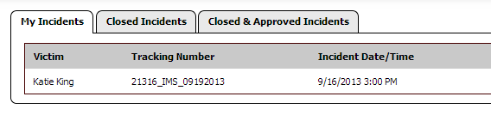**Superintendents** have the ability to select the **Specialist View.** This is done by clicking the computer monitor icon located in the red navigation bar.



No matter which tabs are displayed, incidents are always listed in the area below the tabs. Selecting the various tabs will display different groupings of incidents.

Hovering the cursor over an incident will highlight that incident in gray and make it clickable. Clicking on the highlighted incident will open it so that the user may see the it in detail.

If the Victim column displays a name and then a number in parentheses – for example “John Doe (+3 more)” – there are additional victims besides the one currently displayed. It is possible to add multiple victim to one incident.

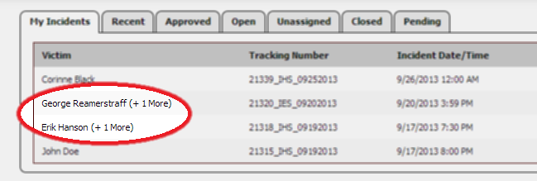

# **NAVIGATION**

The navigation buttons are located in the red banner near the top of the page on the right-hand side. These buttons allow the user to navigate through the different areas of HIBster. All available functions of the software program can be accessed here.

Probably the most commonly used button is the **Home** button. It is available from all pages within HIBster – except for the home screen, of course.



Click **Home** from any page in HIBster to return to the home page.

There are several other navigational buttons available to all users. Depending on which section of the website is being accessed, users will see different combinations of the following options:



Below is a quick breakdown of each icon.

|  |  |
| --- | --- |
|  | **Team HIBster**: Opens a new window which displays the Team HIBster website. |
|  | **View Messages**: Directs user to the Message Center where messages and notifications generated within the system are visible. |
|  | **HIB Grade Assessment**: Click the icon and it will take you to the HIB Grade Assessment page where you can begin a self-assessment. |
|  | **Add new**: Depending on what page users are on, this will create a new item. For instance, on the home page it will create a new an incident. |
|  | **Deleted Incidents**: Takes users to a page where deleted incidents can be restored or searched. |
|  | **Search**: Specify criteria in order to find particular incidents and run reports based on that search. *(See Incidents – “Search Incidents” & Reports)* |
|  | **Specialist View**: Available to Superintendents only. Allows Superintendents to see all incidents within the district. |
|  | **Reports**: Displays a pop-up box where users can generate various reports. *(See Reports)* |
|  | **Yearly Breakdown Report**: Creates a report in a pop-up box which breaks down the number of incidents by month and year. *(See Reports)* |
|  | **Training and Programs**: Displays currents trainings and programs. Also provides ability to create new trainings and programs. |
|  | **Settings**: Available only to System Administrators. Provides ability to edit options to users, schools, documents, and tasks. (*See System Settings*) |
|  | **Feedback**: Users can submit a support question, report a bug, or suggest an enhancement via a pop-up box. *(See Help and Support)* |
|  | **Resources**: Directs users to a different website which lists various helpful resources related to HIBster. *(See Help and Support)* |
|  | **Help**: Directs users to the information page which houses helpful documents, links, video tutorials and support options. |
|  | **Modules Screen**: Allows user to move between the four modules currently available: HIBster, HIBstervention, HIBster PD and Team HIBster. |
|  | **Logout**: Clicking this button logs the user completely out of the HIBster account. *(See Logout)* |

# **INCIDENTS**

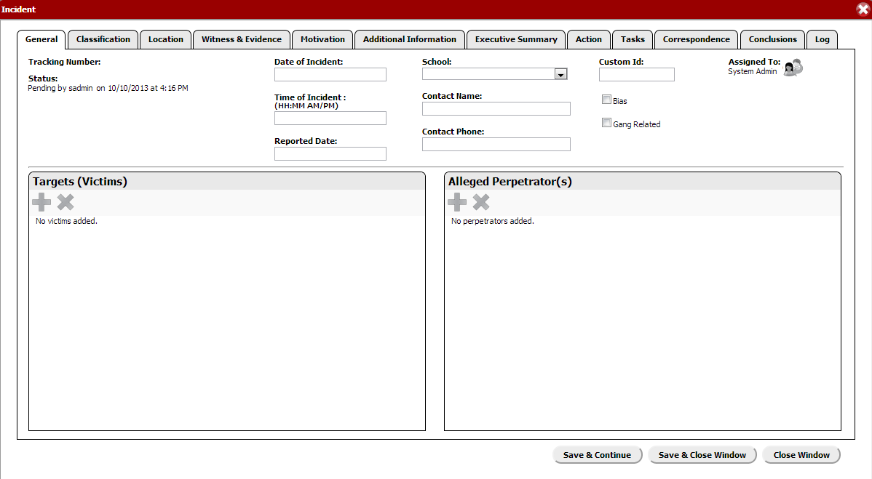

## **Add an Incident (Users)**

*It is our strong recommendation that when working in an incident, users save often. For security purposes, cookies are not enabled and therefore any unsaved information will be lost should your browser crash, the computer lose power or any other type of unfortunate error should occur. Saving regularly will prevent data from being lost in an emergency.*



1. Click the **Add Incident** button in the navigation bar.
2. The **incident** **form** will open. The form contains multiple tabs (as shown in the screenshot above). Each tab consists of a series of fields and questions which help collect information pertaining to a given incident. Users should move from tab to tab, filling in as much information as possible as it becomes available. Users do not need to complete all fields or move linearly from tab to tab, but it is designed in that manner.
3. The **General** tab includes fields for basic information.
   1. **Tracking Number:** HIBster automatically generates a tracking number for the incident when the incident is saved for the first time.
   2. **Status:** HIBster will automatically show when the investigation was started as well as the user who started the investigation. Until an incident is saved, the status will be “Pending.” During the investigation, the status is “Active.” A school administrator can change the status to “Closed” at the end of the investigation. The superintendent will give final approval and the status will change to “Approved.”
   3. **Date of Incident:** Enter the date on which the incident occurred.
   4. **Time of Incident:** Enter the approximate time that the incident occurred.
   5. **Reported Date:** Enter the date on which the incident was reported to school authorities.
   6. **School:** Select the appropriate school from the drop-down list. Select the school that the victim attends.
   7. **Informant Name:** Enter the name of the individual who reported the incident to school authorities.
   8. **Informant Phone Number**: Enter the name of the individual who reported the incident to school authorities.
   9. **Custom ID:** Enter a Custom ID if your district would like to continue with an already established tracking system or for personal reference. *\*Optional\**
   10. **Bias and Gang Related:** If applicable, select whether or not the incident would qualify as Bias Incident or a Gang Related incident.
   11. **Assigned To:** Users can assign incidents to other users throughout the investigation. *(See Incidents – “Assigning an Incident”)*
   12. **Investigation Type**: Select from one of the three options which best describes this incident: HIB, Violence and Vandalism or Code of Conduct
   13. **Targets (Victims) & Alleged Perpetrator(s):** See the instructions below to learn how to enter targets and alleged perpetrators.

### **Add a Victim**

Victims are added to the incident via the Targets (Victim) section. That section is located in the General tab, below the incident information and on the left side of the page.

To add a victim:

1. Click the green plus-sign icon under **Targets (Victims)** header.
   1. If the plus-sign icon is greyed out, click the **Save and Continue** button located at the bottom right of the page. If none of the Save buttons are active, the incident probably is assigned to a different user and cannot be edited. To edit it, the active user must re-assign it first.
2. A pop-up window will appear in which information relating to the victim can be logged. For incidents with multiple victims, simply repeat the process; multiple victims cannot be entered simultaneously.

The following options are available:

* 1. **Victim Type:** From the drop-down menu, select whether the victim is a General Education Student, Student with Disability, Student from Another School, Non-Student, or Unknown.
  2. **Details:** Enter any known details about the victim including **First Name**, **Last Name**, **Address**, **Apt or Suite**, **City**, **State**, **Zip**, **Home Phone**, **Mobile Phone**, **Student ID**, **Age**, **Gender**, **Grade**, and **Ethnicity**.
  3. If applicable, choose whether or not the victim **Caused Injury** or **Incurred Injury.**
  4. **Statement:**
     1. Click the green plus button to add a statement.
     2. **Text Statement:** You can manually type a text statement in the box.
     3. **File Statement:** You can click **Choose File** to upload a statement.
     4. Click **Save & Add** to save that statement and add another or click **Save & Close** to save that statement and go back to the perpetrator box.
  5. At any point, you can **Save & Continue**. When you are finished, you can select **Save & Close** to go back to the incident. You can always modify a victim by clicking the blue pencil.
  6. To delete a victim, click the red “x”.
  7. Add as many Targets (Victims) as necessary by repeating the same process.

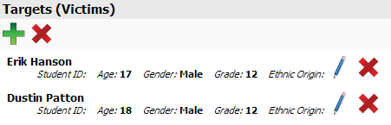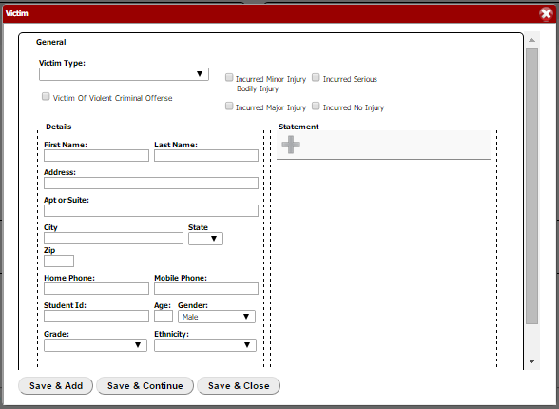

Next you can add the **Alleged Perpetrator(s)**. This is where you can indicate which student(s) allegedly bullied the victim(s).

### **Add an Alleged Perpetrator**

1. Click the green plus button under **Alleged Perpetrator(s)**.   
     
   *If the plus button is greyed out, click* ***Save and Continue*** *first.*

*If you cannot save, you may not be assigned to this incident.*

1. A box will pop up in which you can fill in any information that you know about the alleged perpetrator.
   1. **Perpetrator Type:** From the drop-down menu, select whether the victim is a General Education Student, Student with Disability, Student from Another School, Non-Student, or Unknown.
   2. **Details:** Enter any known details about the alleged perpetrator including **First Name**, **Last Name**, **Address**, **Apt or Suite**, **City**, **State**, **Zip**, **Home Phone**, **Mobile Phone**, **Student ID**, **Age**, **Gender**, **Grade**, and **Ethnicity**.
   3. If applicable, choose whether or not the alleged perpetrator **Caused Injury** or **Incurred Injury.**
   4. **Statement:**
      1. Click the green plus button to add a statement.
      2. **Text Statement:** You can manually type a text statement in the box.
      3. **File Statement:** You can click **Choose File** to upload a statement.
      4. Click **Save & Add** to save that statement and add another or click **Save & Close** to save that statement and go back to the perpetrator box.
   5. At any point, you can **Save & Continue**. When you are finished, you can select **Save & Close** to go back to the incident. You can always modify an alleged perpetrator by clicking the blue pencil.
   6. To delete an alleged perpetrator, click the red “x.”
   7. Add as many Alleged Perpetrators as necessary by repeating the same process.

### **Repeat Victims and Offenders**

One way that HIBster helps you identify trends within your schools is to alert you to instances of Repeat Victims and Repeat Offenders. When you enter a student that has been involved in more than one incident as a victim or offender, a pop up box will notify you of how many incidents the student has been involved in.

## **Submit an Incident (Non-Users)**

Each district has its own unique “Reporting Form URL.” This form can be placed on your district’s website internally to be used by teachers and staff as well as externally to be used by students, parents, volunteers, and the general public.

1. **General**
   * **General**: Fill out all known information regarding the **Date of Incident**, **Time of Incident**, **School** in which the incident took place, and how you learned that a student may have been a victim of harassment, intimidation, or bullying.
   * **Target (Victim)**: Fill out all known information regarding the target’s **First Name**, **Last Name**, **Gender**, and **Grade**.
   * **Alleged Perpetrator(s)**:Fill out all known information regarding the alleged perpetrator’s **First Name** and **Last Name**. More than one perpetrator can be added.
   * **Contact Info**:Anyone who is **not** employed by the school district may report the event anonymously by leaving the contact fields blank. Employees **must** enter their names. The submitter may enter their email address if they would like to receive a copy of the incident they are about to submit. If a phone number is entered, the submitter may indicate what time of day is best to contact them – morning, afternoon, or evening.
2. **Classification**
   * This tab contains fields that describe specific actions performed against the victim. This includes **Verbal & Physical**, **Emotional & Electronic**, **Violence & Vandalism**, **Substance Offense**, and **Weapons/Bombs**. Multiple selections may be made using the checkboxes. For each category, there is also an “Other” option.
3. **Location**
   * This tab contains fields that describe where the incident occurred, such as a classroom, restroom, bus stop, etc. Again, multiple selections may be made using the checkboxes and there is an “Other” option.
4. **Witnesses**
   * Fill out all known information regarding any witness’ **First Name** and **Last Name**. More than one witness can be added. Multiple selections can be made under **Physical Evidence** and there is an “Other” option.
5. **Motivation**
   * This tab asks for reasons the bullying may have occurred, such as appearance, gender, religion, disability, race, sexual orientation, etc. Multiple selections may be made using the checkboxes and there is also an “Other” option.
6. **Additional Info**
   * Enter any additional relevant information that you would like to provide.

Once this form is complete, click **Submit** and the incident will be added to the Pending Incidents Queue.

## **Pending Incidents Queue**

Specialists, School Administrators, and District Coordinators have a tab within their incident manager labeled “Pending.” All incidents that are submitted via the Reporting Form URL will appear in the Pending Incident Queue.

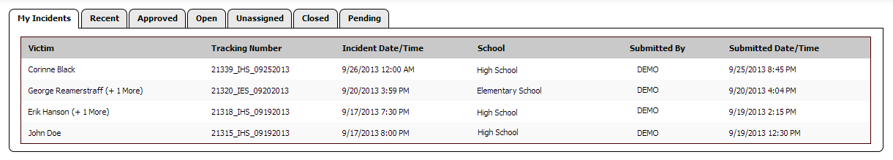

To view the pending incident, click anywhere within the incident’s row.

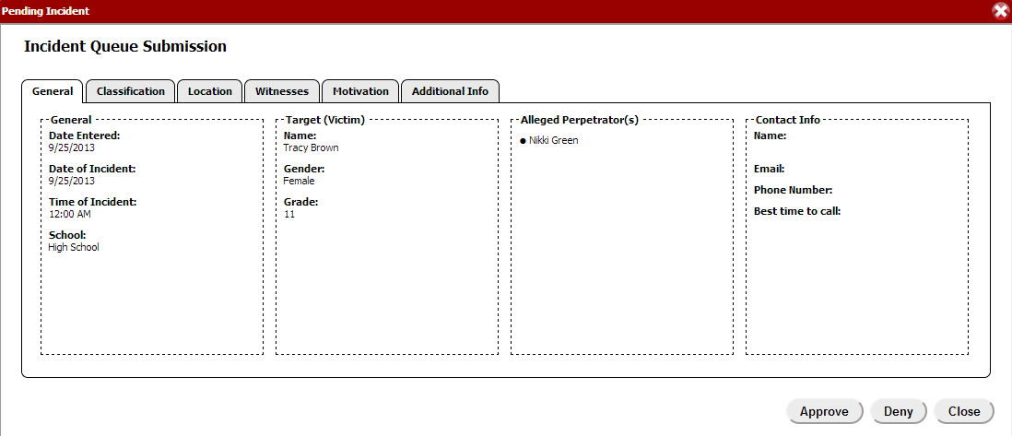

After reviewing the details of the submitted incident, Specialists, School Administrators, and District Coordinators have the ability to **Approve**, **Deny**, or **Close** the incident.

* Once **approved**, the details of the submitted incident will be auto-populated into an incident form and the investigation can continue from that point as usual. Approved incidents from the pending incident queue can be found in the **Unassigned Incidents** tab until they are assigned to a user. *(See Incidents – “Assigning an Incident”)*
* **Denied** incidents will be removed from the Pending Incident Queue and **will not** become actual incidents within the system. Remember that all potential bullying incidents must be investigated; the deny option exists so that users still have discretion as to whether or not incidents were submitted honestly and seriously.
* Before making a decision, users can always **close** the incident and come back to it later for approval or denial.

## **Investigating an Incident**

HIBster employs a tab system to ensure and facilitate the thorough investigation of each incident.

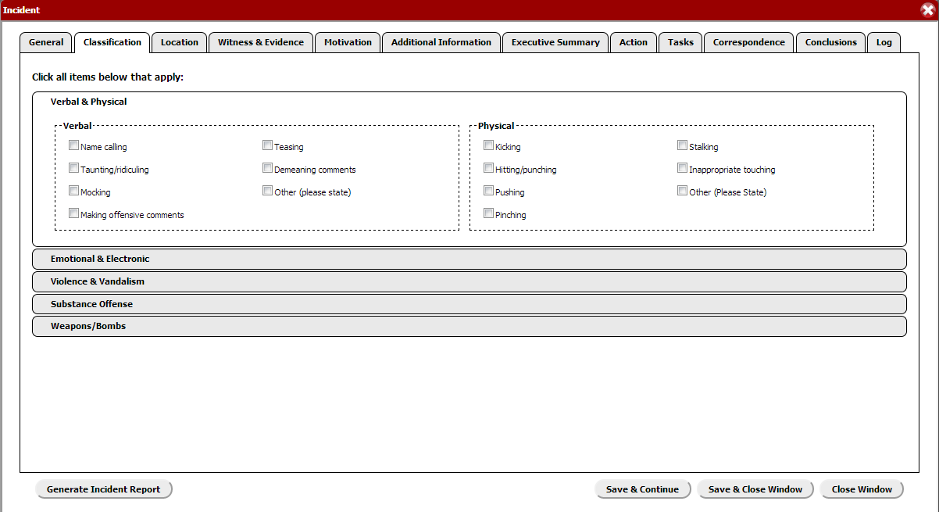

**Classification:** This tab contains fields that describe specific actions performed against the victim. This includes **Verbal & Physical**, **Emotional & Electronic**, **Violence & Vandalism**, **Substance Offense**, and **Weapons/Bombs**. Multiple selections may be made using the checkboxes. For each category, there is also an “Other” option.

**Location:** This tab contains fields that describe where the incident occurred, such as a classroom, restroom, bus stop, etc. Again, multiple selections may be made using the checkboxes and there is an “Other” option.

**Witness & Evidence:** Select **“Yes”** or **“No”** to indicate whether or not there is physical evidence for the incident. If you select "Yes,” multiple selections may be made using the checkboxes and there is also an “Other” option. To add one or more witnesses and their respective statements, follow the same process used to add Victim(s) and Alleged Perpetrator(s).

**Motivation:** This tab asks for reasons the bullying may have occurred, such as appearance, gender, religion, disability, race, sexual orientation, etc. Multiple selections may be made using the checkboxes and there is also an “Other” option.

**Additional Information:** This tab is meant to archive all of your investigation notes. We encourage you to enter **all** other information that you feel is relevant or important to the incident here. This section is for internal use only and will not be included in executive level reports.

**Executive Summary:** This tab features another text area for you to enter a summary of the incident. In a couple of sentences, give a brief summary of the incident. This summary will be included in executive level reports and therefore must be confidential. E.g. Student 1 punched Student 2. Bullying was founded.

**Action:** This tab asks for details of any interventions (parent/guardian contact, disciplinary, non-disciplinary, etc.) that may have occurred. You can specify **Action** taken, **Non-Disciplinary** and **Disciplinary** interventions, and **Program Locations** for all victims and all perpetrators. Multiple selections may be made using the checkboxes. For each category, there is also an “Other” option.

**Tasks:** This tab lists completed and incomplete tasks. Each task has a certain number of days required to complete it as well as a deadline date. System Administrators may customize these notifications and tasks in the system settings. *(See System Settings – “Tasks”)* To mark a task complete, simply click on the task, check the box next to **Completed** and **Save & Close**. If a task is not completed within the number of days, HIBster will send a notification to the user that the incident is assigned to.

**Correspondence:** From this tab, you can auto-generate important documents. Documents intended for correspondence with Parents/Guardians are on the left-hand side and documents intended for correspondence with the State are on the right-hand side. The System Administrator can customize reports and letters in the system settings which can then be auto-populated from the Correspondence tab for each individual incident. *(See System Settings – “Documents”)*

**Conclusions:**This tab allows you to conclude the investigation by selecting the **Type** (category that the incident falls in) and whether the incident was **Founded** or **Unfounded** as bullying as a result of the investigation. Likewise, you can mark each individual perpetrator as **Founded** or **Unfounded**. School Administrators can **Close** the incident from this page and Superintendents can **Approve** the incident from this page.

**Log:** This tab tracks all reassignments of incidents generating an **Audit** Trail as well as **Notes** between users throughout the investigation.

*(For information on how to generate a report on an individual incident at any time during your investigation, see Reports – “Generate Incident Report (Individual Incident)”)*

## **Assigning an Incident**

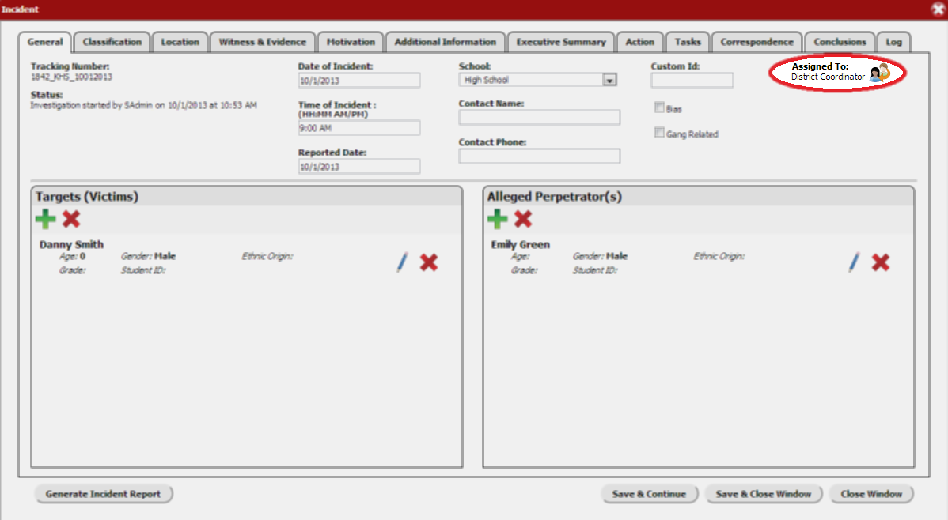Throughout the investigation, the incident can be assigned to another user. For instance, a Specialist may assign the incident to their School Administrator for disciplinary action and review and then the School Administrator may then assign the incident to the Superintendent for final approval.

To reassign an incident,

1. 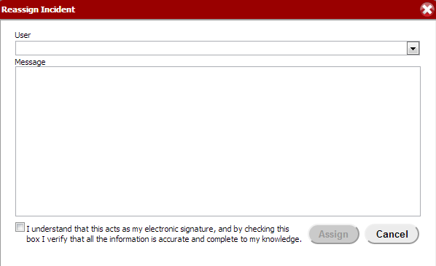Click the **Reassign Incident** icon in the top, right-hand corner of the incident.
2. In the box that pops up, choose the user that you want to assign the incident to from the drop-down list and enter any message that you would like to send to that user.
3. Check the box that says, “I understand that this acts as my electronic signature, and by checking this box I verify that all the information is accurate and complete to my knowledge.” This serves as your electronic signature.
4. Click **Assign** when you are finished. *The person being assigned should receive an email notification. If they do not, the system admin should check and make sure their email address is listed correctly in their account.*

## **Closing an Incident**

After the thorough investigation of an incident, a school administrator may take necessary disciplinary action (documented in the Action tab). Once the incident has been investigated and action taken to his/her satisfaction, conclusions are to be documented in the Conclusions tab. The School Administrator or District Coordinator may then **Close** the incident and assign it to the Superintendent for final approval. The **Status** (found on the General tab of the incident) will then indicate that the incident is **Closed**, the user who closed it, and the date and time at which it was closed. The incident will now also appear in the “Closed” tab of the incident manager.

## **Approving an Incident**

The Superintendent has the final component of any investigation. Once an incident is assigned to him/her and is verified to be thoroughly investigated and action taken to his/her satisfaction, the incident can be **Approved**. This button (for Superintendents only) is also found in the Conclusions tab. Once the incident is **Approved**, it will also appear in the “Approved” tab of the incident manager.

## **Modify an Incident**

An incident may be modified at any time during the investigation. Select “Home” from the navigation icons and find the incident that you want to find within the incident manager, clicking it to open the incident. Modify the incident as needed and save these changes.  
  
Unless an incident is assigned to you, it will be **read only**. Anyone not assigned to an incident may view that incident but not make changes.

**Search Incidents**

1. Click the **Search** icon in the navigation bar.
2. 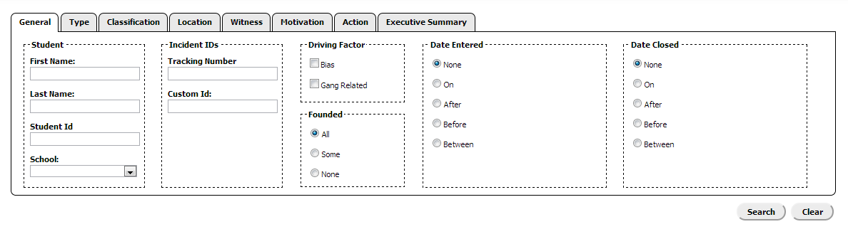The form that appears is very similar to the incident form itself. You can enter search criteria under the **General**, **Type**, **Classification**, **Location**, **Witness**, **Motivation**, and **Action** tabs.
3. The **Executive Summary** tab is for administrators. Anything typed in this tab will be featured as the first page of an Executive Report. This can be used to address, for example, the members of the Board of Education in an executive report being submitted to them.
4. 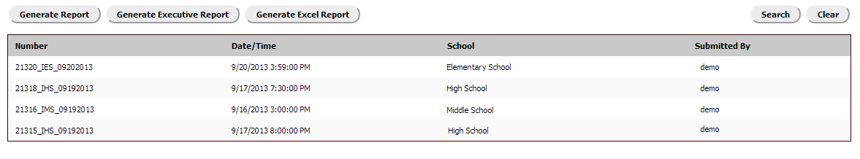After you click **Search**, a list of incidents matching your criteria will generate below.
5. From your results, you can **Generate Report**, **Generate Executive Report**, or **Generate Excel Report**. *(See Reports – “Reports on Search Results”)*

# **REPORTS**

HIBster features many different reports that can be generated for individual incidents, groups of incidents based on certain criteria, and incidents in schools and districts overall.

## **Reports on Individual Incidents**

### **Incident Summary Report**

At any time during the investigation of an incident, an incident report can be generated. There is no limit on how much information must be entered to generate a report.

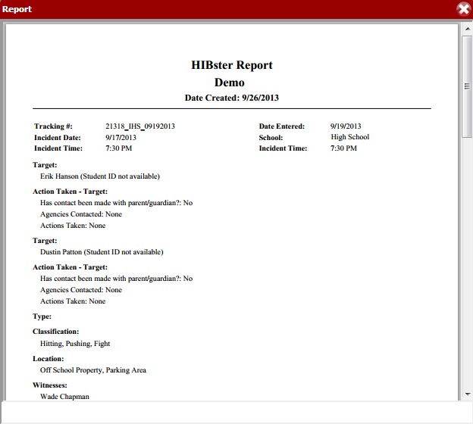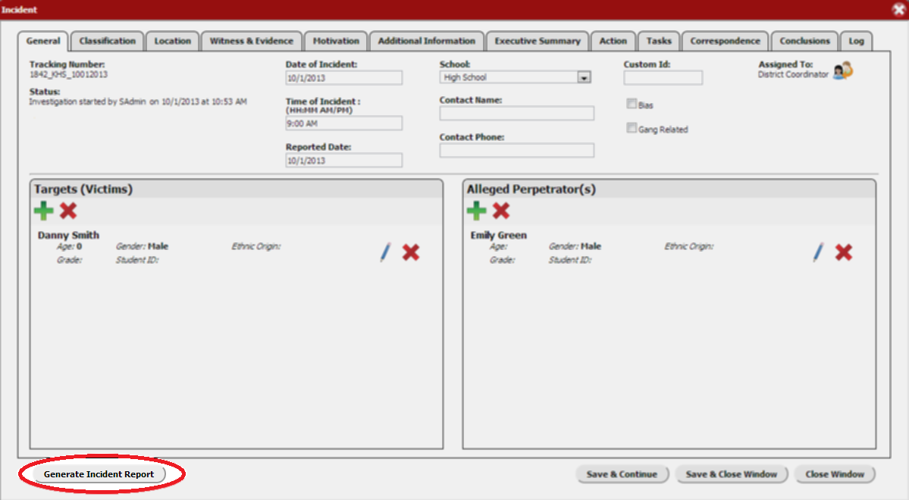

At the bottom, left-hand corner of the incident page click **Generate Incident Report** and a box will pop up with a report on the information within the incident. This report can be saved and printed as a PDF.

**\***Incident reports are for internal use only. They use student names and are therefore not confidential.

### **Statistical Analysis**

The Statistical Analysis tool allows you to compare your incident to similar closed incidents within your state. Deciding whether an incident is or is not harassment, intimidation, or bullying will always be a somewhat subjective process. It can be difficult in some situations to make a definite decision, but the state requires that incidents are reported as such: definite cases of bullying. This tool was designed to make the decision a little easier by comparing the details of your incident to similar closed incidents in your state and creating statistics based on their outcomes.

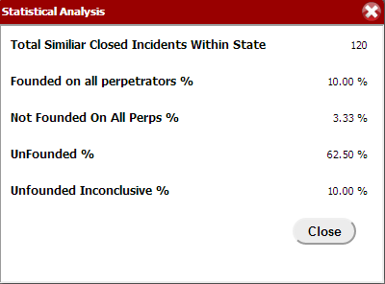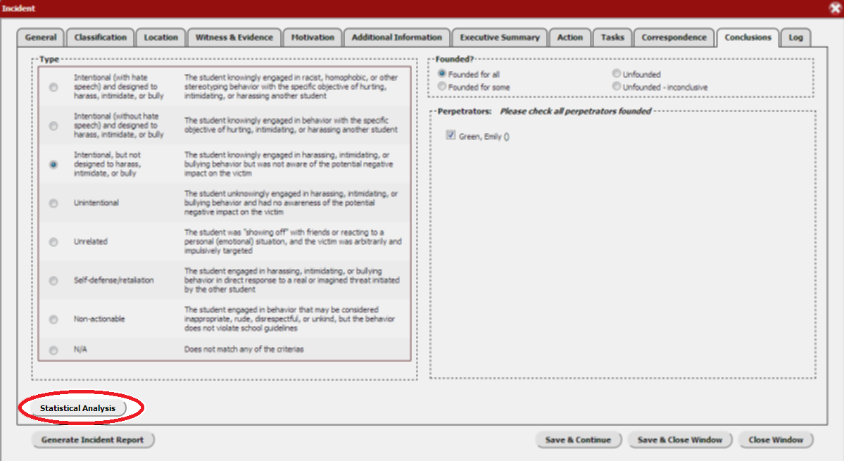

At the bottom, left-hand corner of the Conclusions tab, click **Statistical Analysis** and a box will pop up with the results for your specific incident. The analysis will tell you the **Total Similar Closed Incidents within the State**, and the percentages of which were **Founded on all perpetrators**, **Not Founded on all perpetrators**, **Unfounded**, and **Unfounded Inconclusive**.

The statistical analysis tool compares information between incidents found in the Classification, Motivation, and Type tabs.

## **Reports on Groups of Incidents**



Three different types of reports can be generated on search results. *(For more information regarding the search feature, see Incidents – “Search Incidents”)*

### **District Summary Report**

From the results of your incident search, click **Generate Report**.

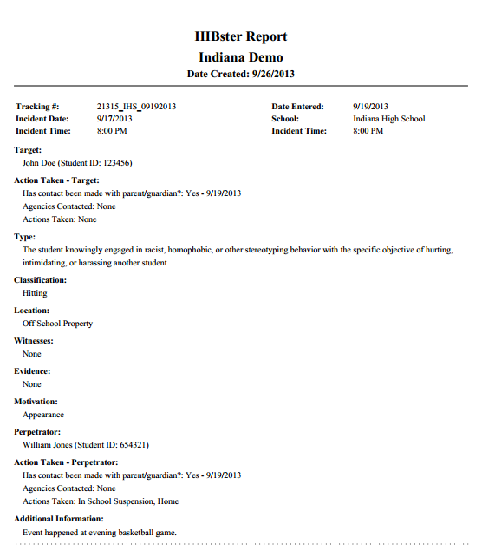

The report generated from the search results is in the same format as a report generated from an individual incident. When generated on a group of incidents from a search, however, the report will feature a one page summary for each incident in that group. This report can be saved and printed as a PDF.

**\***These reports are for internal use only. They use student names and information contained in the additional information tab and are therefore not confidential.

### **Generate Executive Report**

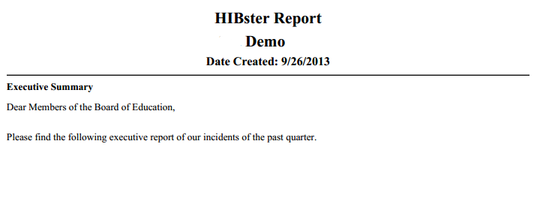From the results of your incident search, click **Generate Executive Report**.  
  
*Remember to type any executive summary information in the **Executive Summary** tab of the search feature **before** clicking search to have it included as the first page of an executive report. *(See Incidents – “Search Incidents)*

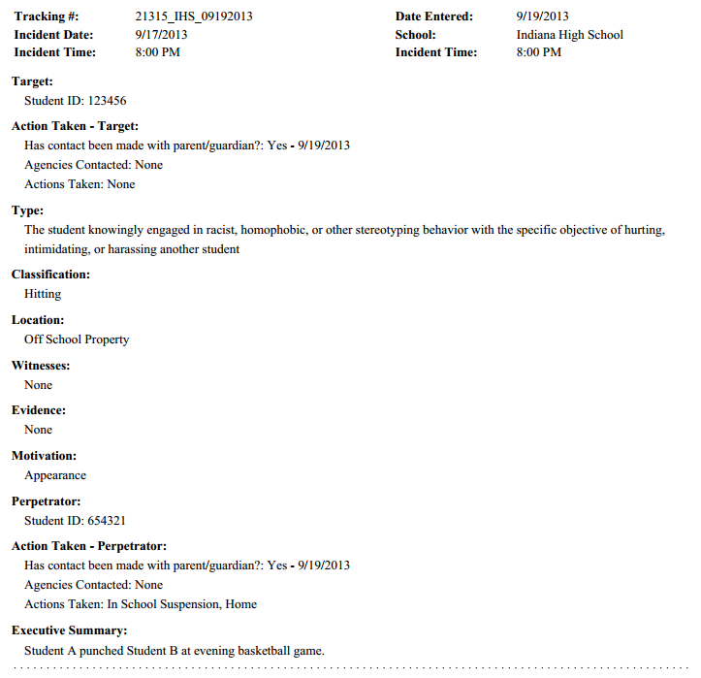

The first page of your executive report   
will include the executive summary  
that was entered in the **Executive**  
**Summary** tab.

Each following page will be a summary  
report of each incident, similar to the  
incident reports. However, the   
executive report uses only Student ID  
numbers and information contained   
in the executive summary tab of the   
incident itself and is therefore   
confidential.

This report can be saved and printed as a PDF.

### **Generate Excel Report**

Another confidential, executive level report that can be generated is the excel report. This report is in Microsoft Excel format rather than PDF format and is an abridged version of the executive report.



The excel report will compile the results of your search into a report featuring the following criteria:

* **School** in which the incident occurred
* **Alleged Aggressor(s)** involved in the incident
* **Grade** of the alleged aggressor(s)
* **Alleged Victim(s)** involved in the incident
* **Grade** of the alleged victim(s)
* **Date of Initial Report** of the incident
* **Date of Written Report** of the incident (when the incident was entered into HIBster)
* **Reported Incident** – The executive summary of the incident itself
* **Results of Investigation (HIB/Not HIB)** – Whether or not the incident was founded or unfounded as a case of harassment, intimidation, and bullying
* **Category** – The selection motivation(s) of the incident
* **Remediation/Discipline Assigned** – Disciplinary and non-disciplinary details of the action tab of the incident
* **How was Parent/Guardian Notified?** – Details from the parent/guardian notification component of the action tab of the incident

## **District & School Reports**

There is also a separate section for Reports and Graphs within HIBster.

From the navigation bar, click the **Reports** icon.

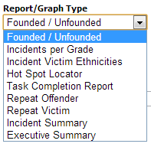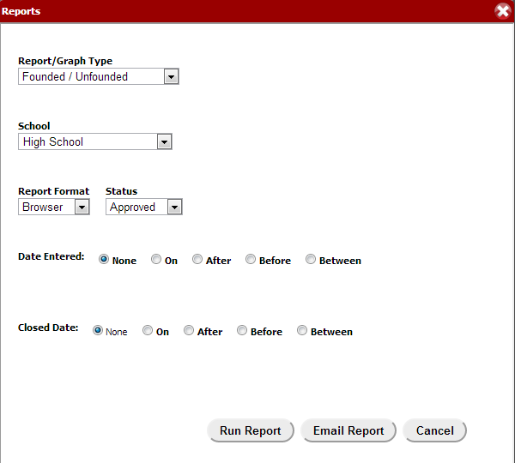

The box that pops up, called Reports, gives you many different options for generating reports based on the incidents for your schools.

1. **Report/Graph Type** *(See Reports – “Report/Graph Types”)*
   * Choose from the following report/graph types: **Founded/Unfounded**, **Incidents per Grade**, **Incident Victim Ethnicities**, **Hot Spot Locator**, **Task Completion Report**, **Repeat Offender**, **Repeat Victim**, **Incident Summary**, and **Executive Summary**.
2. **School**
   * Choose district or the school for which you would like to generate the report/graph.
3. **Report Format**
   * Choose whether you would like to generate the report in a browser window or as a PDF.
4. **Date Entered & Closed Date**
   * Choose and enter your criteria: **None**, **On**, **After**, **Before**, or **Between**
5. **Status**
   * Choose **Approved**, **Not Approved**,or **All** incidents from the drop-down menu
6. Click **Run Report** or **Email Report**

### **Report/Graph Types**

**Founded/Unfounded:** Bar chart that represents the number of Unfounded, Unfounded Inconclusive, Founded All Perps, and Founded Not All Perps incidents within the selected school.

**Incidents per Grade:** Bar chart that represents the number of incidents per grade within the selected school.

**Ethnicities:** Pie chart that represents the percentages of ethnicities involved in incidents within the selected school.

**Hot Spot Locator:** Report that features the total number of incidents within the specified criteria and the number of incidents and percentage of that total that it represents for each location that can be chosen for an incident.

**Task Completion Report:** Pie chart that indicates the percentage of incidents within the specified criteria for which the notifications tasks were “met” or “not met.” If all tasks were completed prior to or on the deadline, the incident will count as “met.” If even one task was not completed or completed after the deadline, the incident will count as “not met.” Information document in the Additional Info tab of the incident is crucial for explaining “not met” incidents.

**Repeat Offender:** Excel report that features the First Name, Last Name, Student ID, Grade, Gender, and Incident Count for students listed as an alleged perpetrator in more than one incident.

**Repeat Victim:** Excel report that features the First Name, Last Name, Student ID, Grade, Gender, and Incident Count for students listed as a target (victim) in more than one incident.

**Incident Summary:** Report identical in format to the non-confidential report generated from search results.

**Executive Summary:** Report identical in format to the confidential executive report generated from search results.

## **Yearly Breakdown Report**

At any point in time, a yearly breakdown report can be generated for the district.

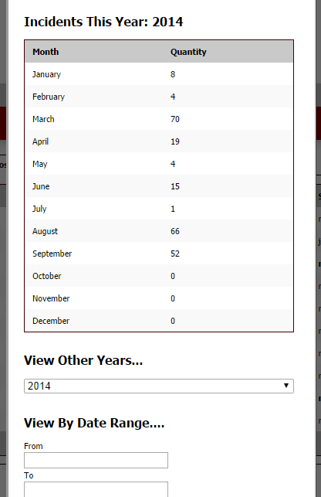From the navigation bar, click the **Yearly Breakdown Report** icon.

A box will pop up with a monthly breakdown of the total number of incidents for the selected year.

Previous years can be chosen from the drop-down list at the bottom of the box and the results will change accordingly.

You can also select by date range. Enter your dates in the **From** and **To** fields.

# **SYSTEM SETTINGS (System Administrators Only)**

System Administrators can access the System Settings for their district’s account.

From the navigation bar, click the **System Settings** icon.

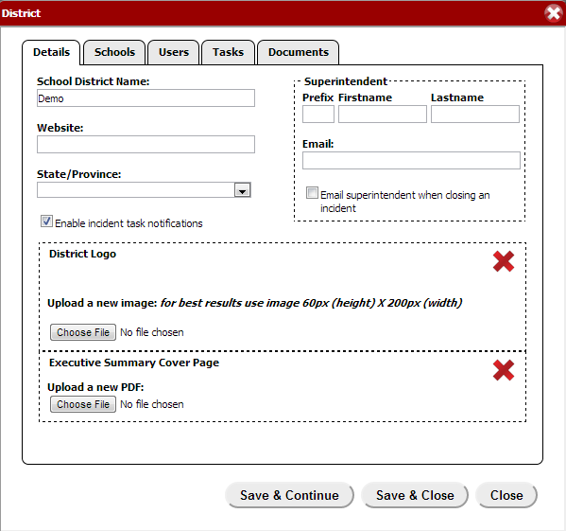

1. **District Details**
   * In the Details tab, you can edit the **School District Name**, **Website**, **State/Province** and **Superintendent’s Prefix**, **First Name**, **Last Name**, and **Email**.
   * If you check the box next to **Enable incident task notifications**, notifications will be sent via email for tasks.
   * If you check the box next to **Email superintendent when closing an incident**, a notification will be sent via email to the superintendent when an incident is closed.
   * Click **Choose File** to upload a **District Logo**
   * Click **Choose File** to upload a new PDF for an **Executive Summary Cover Page**. This will take the place of a typed executive summary for the executive report.

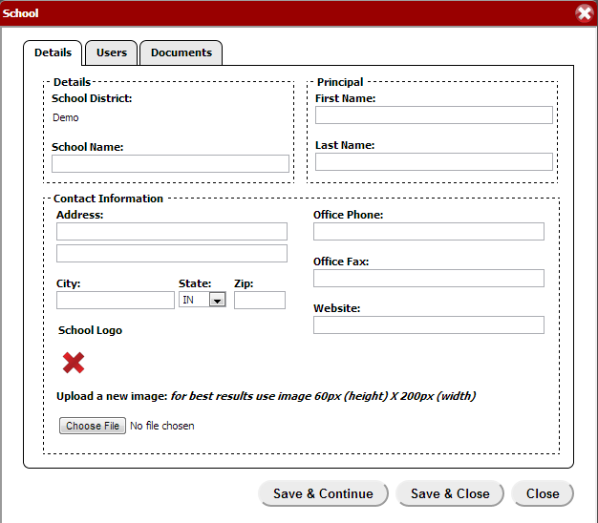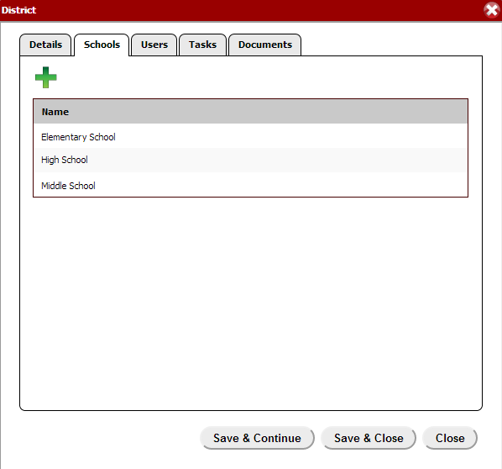

1. **Schools**
   * To add a school, click the green plus button in the top, right-hand corner.
   * Enter the **Details** of the school, the **Principal’s** first and last name, and all known **Contact Information**.
   * Click **Choose File** to upload a **School Logo**.
   * For **Users** and **Documents**, see the information below. The process is the same for both the district overall and for individual schools.

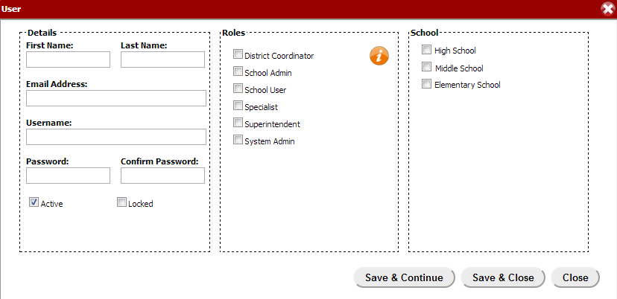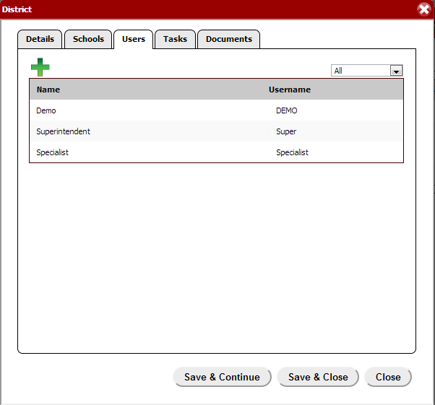

1. **Users**
   * To add a user, click the green plus button in the top, right-hand corner.
   * Enter the **Details** of the user, including their **First** and **Last Name** as well as their **Email Address**.
   * Create a **Username** and **Password** and **Confirm Password**.
     + *You cannot change a username after it has been created.*
     + If the **Active** box is checked, the user account is active.
     + If the **Locked** box is checked, the user account is locked. The system will automatically lock an account after a series of unsuccessful login tries. The system administrator can unlock an account for a user as well as change/reset their password and edit any other details.
   * Choose the **Roles** of the user. The orange “*i*” button explains the access levels of the individual roles. You may choose more than one role for a user.
     + District Coordinators, Superintendents, and System Admins have access to the entire district’s incidents.
     + School Admins, School Users, and Specialists have access to the incidents for **only** the school(s) they are assigned to.
   * Choose the **School** of the user. You may choose more than one school for a user.

*\*Follow the same procedure for Users for an individual school. Users may be entered at either the District or School level.*

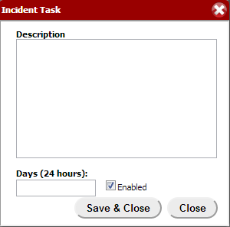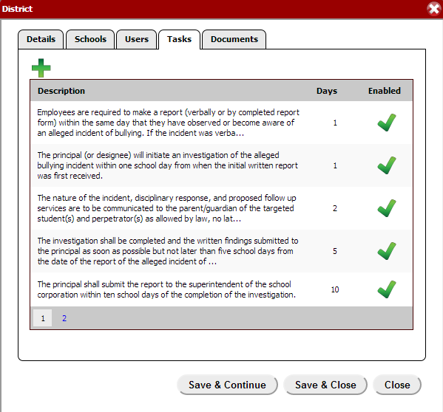

1. **Tasks**
   * For each state, there are default tasks within the system. Each task may be modified by clicking on it and editing within the box that pops up.
   * To add a new task for the district, click the green plus button in the top, right-hand corner.
   * Enter a **Description** for the task as well as the number of **Days** in which you want the task to be completed.
   * If the **Enabled** box is checked, the task will show up in the Notifications tab of each incident.

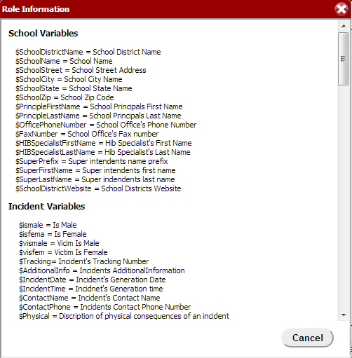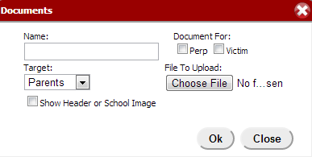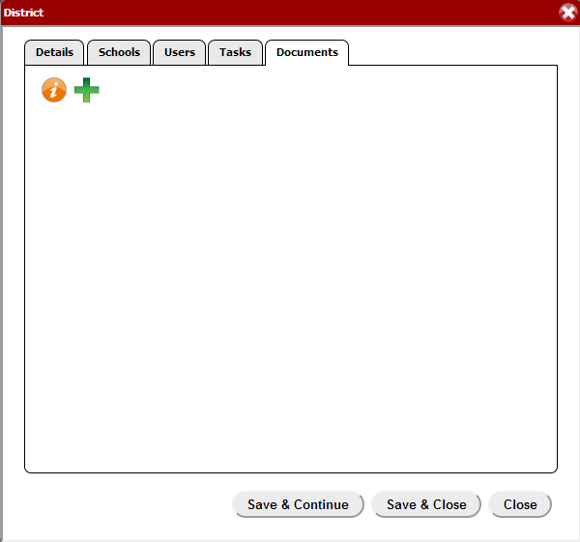

1. **Documents**
   * Custom documents can be created specifically for your district as well as your individual schools using HIBster Variables.
   * Click the orange “*i*” button to see the variables and insert them into your documents accordingly. For instance, if you enter $SchoolDistrictName, HIBster will auto-populate the School District Name wherever that variable occurs in the document.
   * Once you have the appropriate variables saved in your document, click the green plus button to add a new district document.
   * Enter a **Name** for your document.
   * Choose whether the document will be used for a **Perp** or **Victim**.
   * Choose a **Target** for your document: Parents or State
   * If you want the document to show a previously uploaded **Header or School Image**, check the box.
   * Finally, click **Choose File** to select your custom document that includes the HIBster variables. Your document will now be available for auto-population within each individual incident under the Correspondence tab.

# **HELP & SUPPORT**

## **Feedback**

To give us your feedback, click the **Feedback** icon in the navigation bar.

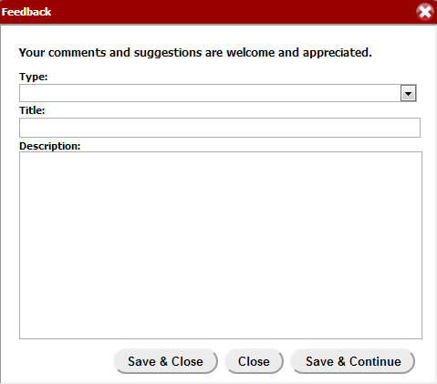  
From the drop-down menu, choose the **Type** of feedback you would like to submit: **Bug**, **Enhancement**, or **Comment.**

Type a **Title** for your feedback, and place the **Description** of your bug, enhancement, or comment in the box.

We appreciate all feedback from our customers and encourage you to use this powerful tool so that we may continue to meet your needs and requests to the best of our ability with HIBster!

## **Resources**

To access HIBster Resources, such as this **User Guide** and **Technical Requirements**, click the **Resources** icon in the navigation bar.

**ADDITIONAL INFORMATION**

* The HIBster system features a time-out mechanism. If the system is idle for 60 minutes, it will automatically log you out for security purposes. Save often to avoid losing any information.